CS-322 Software Construction
Project Plan


Project Management System

PRESENTED BY
MEMBER 1: Tayyab Mehboob (LEADER) (04072213035)
MEMBER 2: M. Hamad (04072213023)
MEMBER 3: M. Ehtisham (04072213026)
Member 4: M. Rayyan (04072312024)

SUPERVISED BY
Dr. Onaiza Maqbool

Department of Computer Science
Quaid-e-Azam University, Islamabad
Project Plan Document Approval Signatures
Project Manager
______________________ _______________________
Signature Date
Tayyab Mehboob
Student, QAU Islamabad
Member 1
______________________ _______________________
Signature Date
M. Hamad
Student, QAU Islamabad
Member 2
______________________ _______________________
Signature Date
M. Ehtisham
Student, QAU Islamabad

Member 2
______________________ _______________________
Signature Date
M. Rayyan
Student, QAU Islamabad

Stakeholder
______________________ _______________________
Signature Date
Dr. Onaiza Maqbool
Professor, QAU Islamabad
Change History

Version No. | Date | Modified  By | Changes
1 | 03/03/2025 | Tayyab Mehboob | Original

Remarks

____________________
Signature

Dr. Onaiza Maqbool
Professor, QAU Islamabad

Table of Contents
Introduction 5
Purpose 5
Scope 5
o Project Name 5
o Main Functionality 5
o Objectives 5
• Definitions, Acronyms, and Abbreviations 5
References 5
• Overview 5
Overall Description 5
• Product Perspective 5
• Product Functions 5
• User Characteristics 5
Constraints 6
• Assumptions and Dependencies 6
Specific Requirements 6
• Functional Requirements (Use Cases) 6
UC 1: Offer Projects and Assign Supervisors 6
UC 2: Project Registration 8
UC 3: Project Approval 9
UC 4: Upload Work Product 11
UC 5: View Work Product 12
UC 6: Give Feedback 13
UC 7: View Feedback 15
• Non-Functional Requirements 18
o Performance Requirements 18
• Security Requirements 18
• Usability Requirements 18
• Reliability Requirements 19
• System Functions 19
• Sub-Functions for Registration 19
o Sub-Functions for Project Management 19
o Sub-Functions for Work Product Upload and Version Control 19
Sub-Functions for Feedback Mechanism 20
Performance Requirements 20
Data Dictionary 20
System Sequence Diagram 22
UC 01:Offer projects and assign Supervisor 23
UC 02: Project Registration 24
UC 03: Project Approval 24
UC 04: Upload work product 25
UC 05: View work product 26
UC 06: Give Feedback 26
UC 07: View Feedback 27
Domain Model 28
Use-case Diagram 29

Introduction

Purpose
This Software Requirements Specification (SRS) document defines the functional and non-functional requirements for the Project Management System, hereafter referred to as "Project Management." Project Management system is designed to facilitate seamless communication between students and their project supervisors throughout the final semester. It provides a centralized platform where projects can be registered, managed, and continuously updated with work product submissions and feedback. This document is intended for use by the development team, project supervisors, students, and other stakeholders to ensure a clear understanding of the system’s capabilities and limitations.

Scope
Project Management system is a web-based project management system dedicated to enhancing the project lifecycle for final semester students within the Department of Computer Science. The system aims to streamline the registration of projects, enable effective communication between students and supervisors, and support the upload of multiple versions of work products along with supervisor feedback.
- Project Name
Project Management system
- Main Functionality
- Communication between Student and Supervisor:
Project Management system allows real-time messaging and notifications to ensure that students and supervisors can discuss project details, clarify doubts, and provide timely guidance.
- Project Registration and Management:
Students can register their projects by submitting essential details, while supervisors can be assigned to oversee each project. The system will maintain a central repository of all project records for easy tracking and management.
- Work Product Submission with Version Control:
Students can upload work products, with support for multiple versions of a single submission. This feature enables supervisors to review progress over time, compare versions, and provide iterative feedback.
- Objectives
- Enhanced Communication:
Facilitate clear and efficient communication between students and supervisors to support academic progress and project quality.
- Streamlined Project Registration:
Simplify the process of project registration and management, ensuring that each project is tracked from initiation through completion.
- Robust Version Control:
Enable students to submit multiple versions of work products, ensuring that supervisors can access and review historical data and progress updates.
- Timely Feedback Mechanism:
Provide a mechanism for supervisors to deliver prompt feedback on submitted work products, aiding in continuous improvement.
- User-Friendly Interface:
Develop an intuitive and accessible user interface that can be used by both students and supervisors with minimal training.

- Definitions, Acronyms, and Abbreviations
- Project management system: The name of the project management system.
- SRS: Software Requirements Specification.
- Supervisor: A faculty member assigned to guide and evaluate the student’s project.
- Student: A final semester student enrolled in the Department of Computer Science.
- Work Product: Any deliverable submitted by a student as part of the project, such as reports, code, or presentations.
- Version Control: A system feature that tracks revisions of submitted work products.
- UI: User Interface.
- API: Application Programming Interface.

References
- IEEE Standard for Software Requirements Specifications (IEEE Std 830-1998).
- ISO/IEC/IEEE 16326:2019 Guidelines for Life Cycle Processes – Project Management.
- Department of Computer Science Project Guidelines, [University/Department internal documentation].
- Web resources on best practices for version control and project management systems (e.g., Git documentation, Agile project management literature).

- Overview
This document is organized to provide a comprehensive understanding of the ProjectConnect system. The SRS is divided into several main sections:
- Introduction: Describes the purpose, scope, definitions, references, and an overview of the SRS.
- Overall Description: Provides details on the product perspective, functionality, user characteristics, constraints, and assumptions.
- Specific Requirements: Outlines in detail the functional requirements (use cases) and non-functional requirements, including system functions and performance criteria.
- Appendices: Includes supporting documentation such as the data dictionary, domain diagrams, system sequence diagrams, and use case diagrams.

Overall Description
- Product Perspective
Project management system is a standalone web-based project management system developed to meet the communication and management needs of final semester projects in the Department of Computer Science. Unlike generic project management tools, Project management system is tailored specifically to the academic environment by facilitating direct communication between students and supervisors, enabling project registration, and supporting iterative work product submissions. The system integrates seamlessly with existing university authentication services and follows standard web application architecture with a dedicated backend server and a responsive user interface.

- Product Functions
Project management system includes the following key functionalities:
- Student and Supervisor Registration:
The system allows new users—both students and supervisors—to register. It manages user profiles and authentication, ensuring that only authorized users can access project data.
- Project Registration and Tracking:
Students can register their projects by submitting detailed project proposals, while supervisors can be assigned to each project. The system maintains a central repository for all project registrations and tracks project status over the semester.
- Uploading Multiple Versions of Work Products:
Students can submit work products related to their projects, with support for uploading multiple versions. This feature ensures that supervisors can review progress, compare revisions, and assess improvements over time.
- Feedback Submission and Review:
Supervisors can provide detailed feedback on each submitted work product. The system supports both textual and, if necessary, file-based feedback to guide students in improving their deliverables.
- User Characteristics
- Students:
Final semester students are expected to have basic computer skills and familiarity with standard web applications. They require an intuitive interface for project registration, work product submission, and receiving feedback.
- Supervisors:
Faculty members or project advisors who may have varying degrees of technical expertise. They need tools to view project submissions, provide feedback, and monitor progress easily.
- System Administrators:
IT personnel responsible for maintaining the system’s operation, security, and data integrity. They require administrative interfaces for user management, system monitoring, and backups.

Constraints
- Time Constraints:
The development and deployment of ProjectConnect must be completed within the academic semester timeframe, typically 14–16 weeks.
- Technology Constraints:
The system will be developed using standard web technologies (e.g., HTML, CSS, JavaScript, and a server-side language such as Java or Python). Integration with existing university systems may impose additional technical requirements.
- User Access and Security:
The application must comply with university data privacy policies and protect sensitive information, including student records and project details.
- Performance Requirements:
The system is required to provide real-time updates for work product submissions and feedback. It should respond within two seconds for most user actions to ensure a smooth user experience.
- Assumptions and Dependencies
- Internet Connectivity:
Users are assumed to have reliable internet access when using the system.
- University Authentication Services:
It is assumed that the system will integrate with the university’s authentication mechanisms to verify user identities.
- Third-Party Libraries and Tools:
The system may depend on established libraries for version control, file uploads, and messaging. It is assumed that these components are reliable and well-documented.
- User Competency:
Both students and supervisors are expected to have a minimum level of digital literacy to operate the system without extensive training.
- System Maintenance:
Regular maintenance, including backups and updates, is assumed to be scheduled during off-peak hours to minimize disruption.

Specific Requirements
- Functional Requirements (Use Cases)

UC 1: Offer Projects and Assign Supervisors
Primary Actor:
Administration

Preconditions:
The system is operational.

The administrator is logged in.

The supervisor has an account and is logged in.

Main Success Scenario:

The administrator enters the project details, including project title, project description, and other required fields.

The administrator assigns a supervisor to the project from the available supervisor list.

The system validates the project details.

The system saves and publishes the projects so that they become available for student registration.

Alternate Scenarios:

Alternate 1.1: If project details are incomplete, the system prompts the administrator to provide the missing information before proceeding.

Alternate 1.2: If the chosen supervisor is unavailable, the system prompts the administrator to select another supervisor.

Alternate 1.3: If the system fails to upload or save the project, the system displays an error message and prompts the administrator to retry.

Postconditions:
Projects are available for students to browse and register.

The assigned supervisor is notified of the project assignment.

UC 2: Project Registration
Primary Actor:
Student

Preconditions:

The student has a valid user account and is logged in.

The student is eligible (a final year student) to register for a project.

Main Success Scenario:

The system displays a list of available projects after the student browses the project menu.

The student selects a project and submits a registration request.

The system verifies that the student is eligible for the project.

The system confirms the registration and updates the project status.

The system notifies the assigned supervisor of the new project registration.

The student receives confirmation of registration.

Alternate Scenarios:

Alternate 2.1: If the student changes their mind during the registration process, the student cancels the registration, and the system does not register the project.

Alternate 2.2: If the student is not eligible for project registration, the system displays an appropriate error message and does not process the registration.

Alternate 2.3: If registration fails due to a system error, the system displays an error message and prompts the student to retry.

Postconditions:

The student has successfully registered for the project.

The supervisor receives a notification about the new registration.

UC 3: Project Approval
Primary Actor:
Supervisor

Preconditions:

A student has registered a project.

The supervisor is logged in.

Main Success Scenario:

The supervisor selects the project from their project menu that has been registered by a student.

The system displays the student’s project proposal and attached details.

The supervisor reviews the project proposal and associated details.

The supervisor approves or rejects the project by selecting the corresponding option.

The system updates the project status accordingly (approved or rejected) and saves the decision.

Alternate Scenarios:

Alternate 3.1: If the supervisor encounters a system error during approval, the system notifies the supervisor and prompts for a retry.

Alternate 3.2: If the project requires modifications, the supervisor sends feedback to the student before final approval, and the system records the feedback.

Postconditions:

The project status is updated as approved or rejected.

The student and supervisor are both notified of the updated project status.

UC 4: Upload Work Product
Primary Actor:
Student

Preconditions:

The student has an approved project registration.

The student is logged in.

Main Success Scenario:

The student navigates to their project page where the project details and options are displayed.

The system displays an “Upload Work Product” option.

The student selects the “Upload Work Product” option, attaches the file (or files) containing the work product, and submits the upload request.

The system validates the file format and size.

The system stores the work product, assigns a version identifier, and records a timestamp.

The system notifies the assigned supervisor that a new work product has been uploaded.

Alternate Scenarios:

Alternate 4.1: If the file format is unsupported, the system displays an error message and prompts the student to use a supported format.

Alternate 4.2: If the upload fails due to a system error, the system displays an error message and prompts the student to retry the upload.

Postconditions:

The work product is successfully saved in the system with version control.

The supervisor receives a notification regarding the new work product submission.

UC 5: View Work Product
Primary Actor:
Supervisor

Preconditions:

The student has uploaded at least one work product.

The supervisor is logged in.

Main Success Scenario:

The supervisor navigates to the assigned student’s project page from the supervisor’s project menu.

The system displays a list of uploaded work products for the selected project.

The supervisor selects a work product from the list to view it in detail.

The system opens the file and displays the document for review.

Alternate Scenarios:

Alternate 5.1: If the file is missing or corrupt, the system notifies the supervisor of the issue.

Alternate 5.2: If the system encounters a loading error, the system displays an error message and provides a retry option.

Postconditions:

The supervisor successfully accesses and reviews the work product.

UC 6: Give Feedback
Primary Actor:
Supervisor

Preconditions:

The student has uploaded a work product.

The supervisor is logged in.

The student is logged in (for receiving real-time notifications).

Main Success Scenario:

The supervisor navigates to the student’s submitted work product from their project menu.

The system opens the selected work product.

The supervisor reviews the work product and enters feedback comments in the provided field.

The supervisor submits the feedback.

The system saves the feedback and sends a notification to the student that new feedback is available.

Alternate Scenarios:

Alternate 6.1: If feedback submission fails due to a system error, the system displays an error message and prompts the supervisor to retry submitting the feedback.

Alternate 6.2: If the supervisor wants to edit previously submitted feedback, the system allows updating the comments, and then saves the revised feedback.

Postconditions:

The feedback is saved and becomes visible to the student.

The student receives a notification of the new feedback.

UC 7: View Feedback
Primary Actor:
Student

Preconditions:

The supervisor has submitted feedback for the student’s work product.

The student is logged in.

Main Success Scenario:

The student navigates to the project feedback section on the project page.

The system displays a list of work products for which feedback is available.

The student selects a specific work product to view its feedback.

The system displays the feedback provided by the supervisor.

Alternate Scenarios:

Alternate 7.1: If feedback is missing or not yet available, the system informs the student accordingly.

Alternate 7.2: If the student wishes to respond to the feedback, the system provides an option to send a query to the supervisor.

Postconditions:

The student successfully views the feedback.

If applicable, the student may initiate further communication with the supervisor regarding the feedback

- Non-Functional Requirements

- Performance Requirements
- The system must process user registration and project submission requests within 2 seconds.
- Work product uploads and version control operations should complete within 3 seconds.
- Feedback submissions must be processed and displayed within 2 seconds.
- The system should support concurrent users (students and supervisors) without performance degradation.
- Security Requirements
- All user data, including project details and work products, must be stored securely using encryption.
- The system shall implement role-based access control to ensure that students can only access their own projects and supervisors only their assigned projects.
- Secure authentication mechanisms (e.g., two-factor authentication) should be implemented for both registration and login.
- The system must comply with data privacy regulations as mandated by the university.
- Usability Requirements
- The user interface shall be intuitive and responsive, with clear navigation for students and supervisors.
- All forms must include inline validation to help users correct errors immediately.
- The system should provide help documentation and tooltips for key functions.
- Mobile responsiveness is required so that the system can be accessed from various devices.
- Reliability Requirements
- The system should have a 99.5% uptime during academic sessions.
- Automatic backups must be performed regularly to prevent data loss.
- The system must support real-time notifications to ensure prompt communication between users.
- Recovery mechanisms must be in place to restore operations quickly in case of system failure.
- System Functions
- Sub-Functions for Registration
- ValidateInputDetails():
Checks that all mandatory fields (e.g., name, email, password) are provided and meet security standards.
- SendConfirmationEmail():
Sends an email to the user for verification of registration.
- VerifyEmailConfirmation():
Confirms the user's email address based on the provided confirmation code.
  - Sub-Functions for Project Management
- SubmitProjectDetails():
Captures and validates project information provided by the student.
- AssignSupervisor():
Links a supervisor to the project based on project criteria or manual assignment.
- UpdateProjectStatus():
Tracks changes in project status (e.g., Registered, In Progress, Completed).
- Sub-Functions for Work Product Upload and Version Control
- UploadWorkProduct():
Manages the file upload process, ensuring file type and size compliance.
- VersionControlHandler():
Assigns version numbers to each submission and archives previous versions.
- DisplayVersionHistory():
Provides an interface for supervisors to review the evolution of the work product over time.

Sub-Functions for Feedback Mechanism
- SubmitFeedback():
Allows supervisors to provide text-based feedback and, optionally, attach supplementary documents.
- RetrieveFeedback():
Displays all feedback associated with a given work product, sorted by submission date.
- NotificationHandler():
Sends notifications to students when new feedback is available.

Performance Requirements
- Response Time:
All core operations (registration, project submission, work product upload, feedback submission) must complete within 2–3 seconds under normal operating conditions.
- Scalability:
The system must support concurrent access by at least 500 users during peak submission periods without significant performance degradation.
- Data Throughput:
The system must handle frequent data updates, ensuring real-time reflection of project statuses and feedback.
- Backup and Recovery:
Regular backups must be completed within predefined maintenance windows, and system recovery time should not exceed 5 minutes in case of critical failure.

Data Dictionary

Data Element Name | Type | Definition | Data Type | Length | Example | Conditions
Project ID | Data Element | Unique identifier for each project. | Integer | 6 | 101101 | Auto-generated unique ID.
Project Title | Data Element | Title of the project. | String | 30 | AI-based Chatbot | Required, must be unique
Project Description | Data Element | Detailed description of the project. | String | 500 | A chatbot using Machine Learning. | Required meaningful description.
Supervisor ID | Data Element | Unique identifier for each supervisor. | Integer | 6 | 421446 | Auto-generated unique ID.
Supervisor Name | Data Element | Name of the supervisor assigned to the project. | String | 50 | Mam Onaiza Maqbool | Required, must exist in the system.
Supervisor Email | Data Element | Email of the supervisor. | String | 50 | Onaizamaqbool11@gmail.com | Must be a valid email.
Student ID | Data Element | Unique identifier for each student. | Integer | 10 | 873922 | Auto-generated unique ID.
Student Name | Data Element | Name of the student registering for the project. | String | 50 | Tayyab Mehboob | Required
Student Email | Data Element | Email of the student. | String | 50 | tayyabmehboob2003@gmail.com | Must be a valid email.
Project Registration Status | Data Element | Status of the student’s project registration. | String | 15 | Registered | Possible values: Pending, Registered, Cancelled.
Project Approval Status | Data Element | Approval status of the project. | String | 15 | Approved | Possible values: Pending, Approved, Rejected.
Approval Comments | Data Element | Comments provided by the supervisor during project approval. | String | 200 | Make some minor changes to your documentation. | Required
Work product File | Data Element | File submitted by the student. | PDF/Zip | 5-7 MB | Use-case text.pdf | Only pdf or zip file allowed.
Submission Date | Data Element | Date when the student submits the work product. | Date | 10 | 23/03/2025 | Must be in DD/MM/YYYY format.
Submission Status | Data Element | Status of work submission. | String | 15 | Submitted | Possible values: Pending, Submitted, Failed.
Feedback ID | Data Element | Unique identifier for the feedback. | Integer | 10 | 769327 | Auto-generated unique ID.
Feedback Comments | Data Element | Comments provided by the supervisor on student’s work. | String | 200 | Good work, need some changes. | Required
Feedback Date | Data Element | Date when feedback was submitted. | Date | 10 | 28/03/2025 | Must be in DD/MM/YYYY format.
Feedback Status | Data Element | Status of feedback submission. | String | 15 | Completed | Possible values: Pending, Completed, Revised.
Feedback Visibility | Data Element | Determines if feedback is accessible to student. | Boolean | 1 | True | True= Visible  False= Hidden
Supervisor Query Response | Data Element | Supervisor’s response to student queries. | String | 200 | Further clarification on model | Optional

System Sequence Diagram

UC 01:Offer projects and assign Supervisor
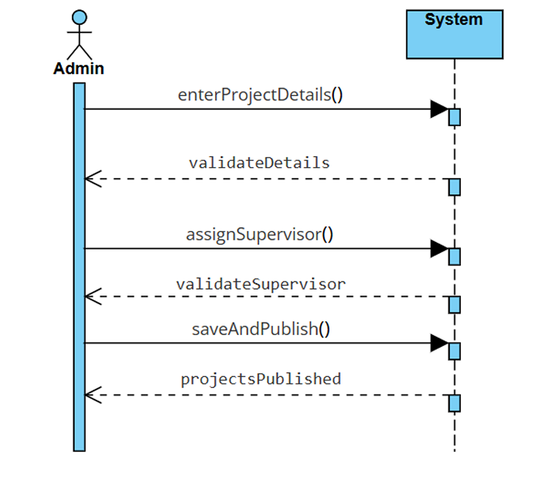

UC 02: Project Registration
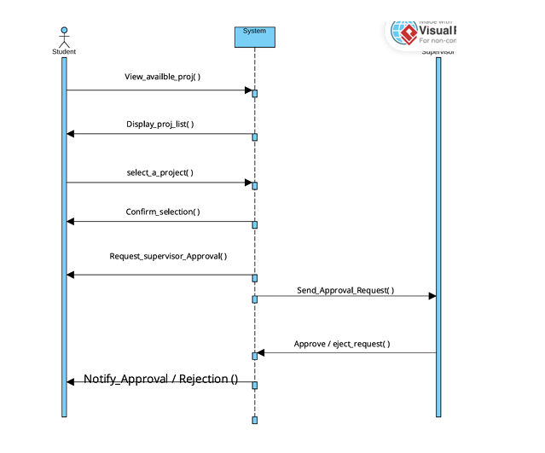

UC 03: Project Approval

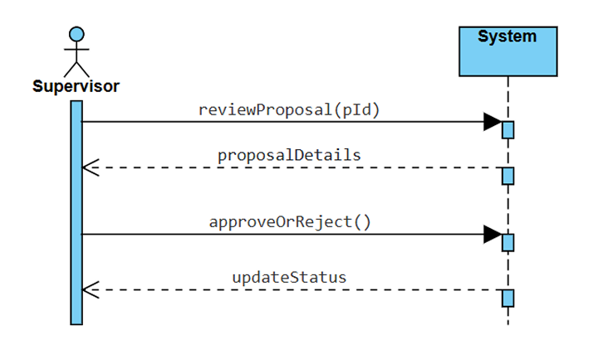

UC 04: Upload work product
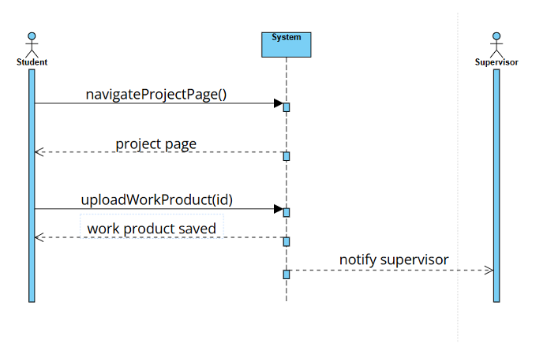

UC 05: View work product
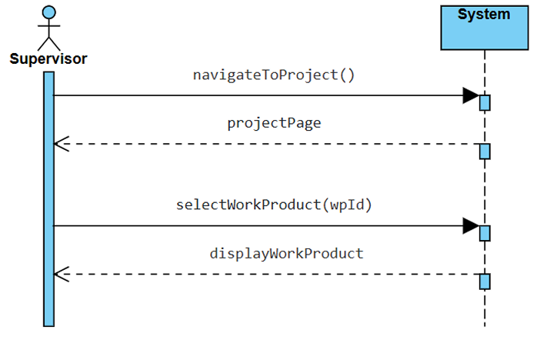

UC 06: Give Feedback
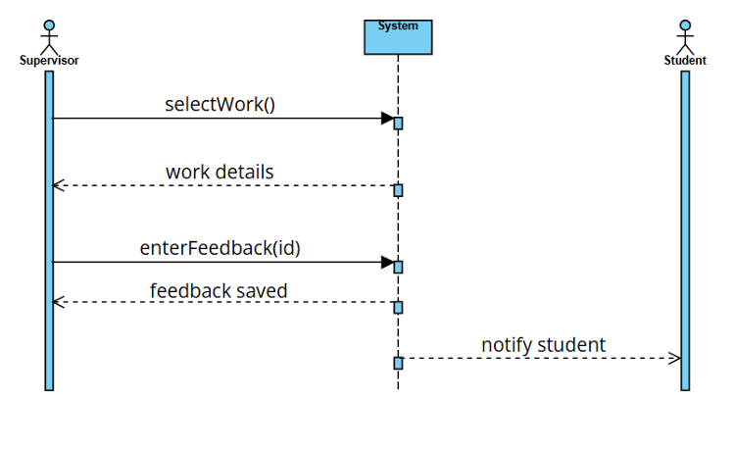

UC 07: View Feedback
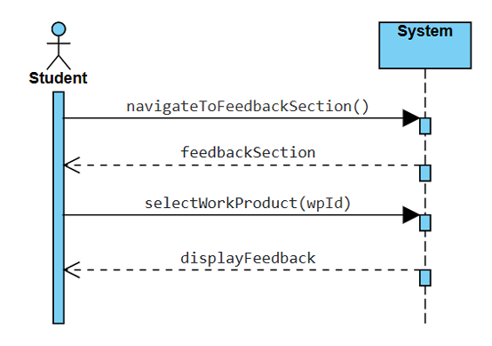

Domain Model
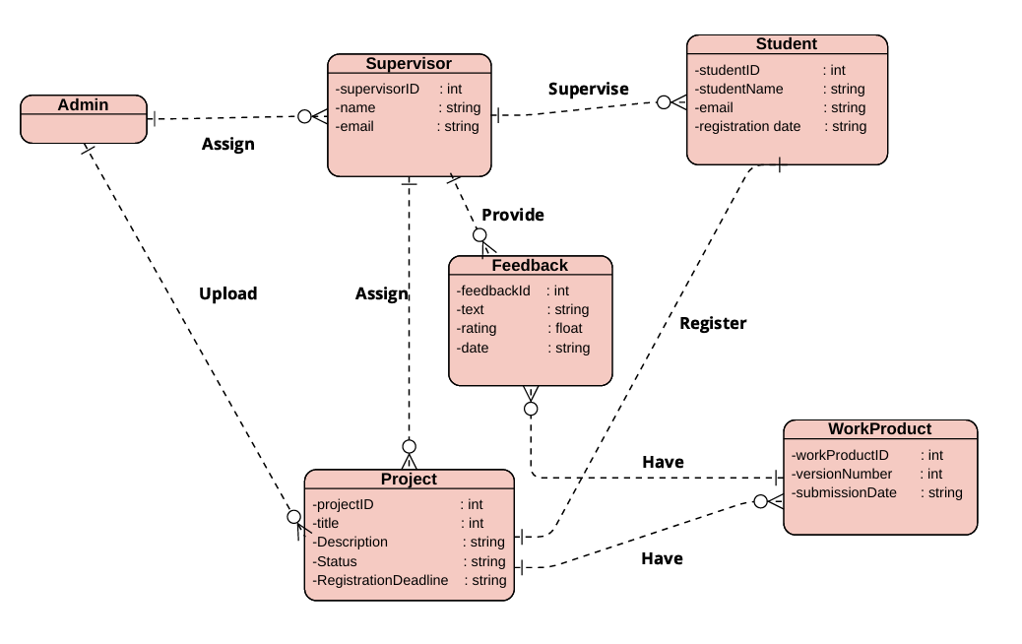

Use-case Diagram
